**Queue creation using CLI :**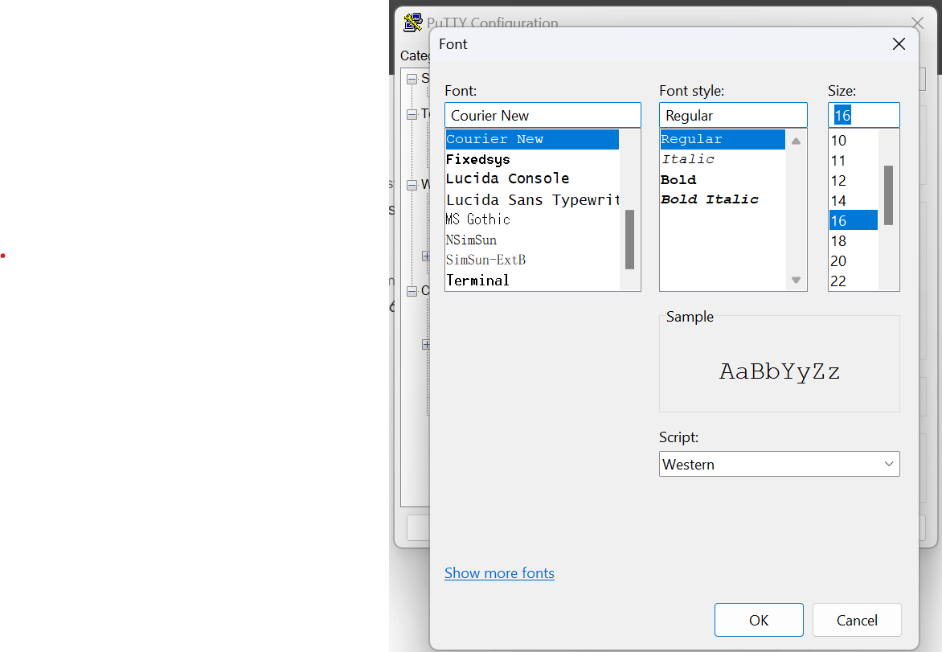

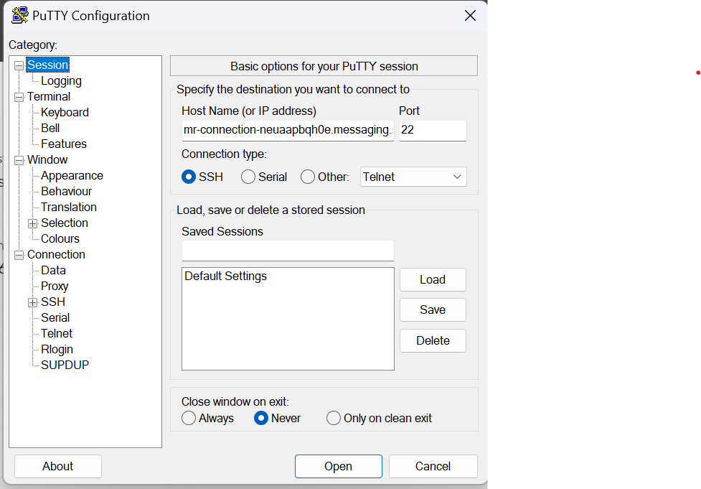

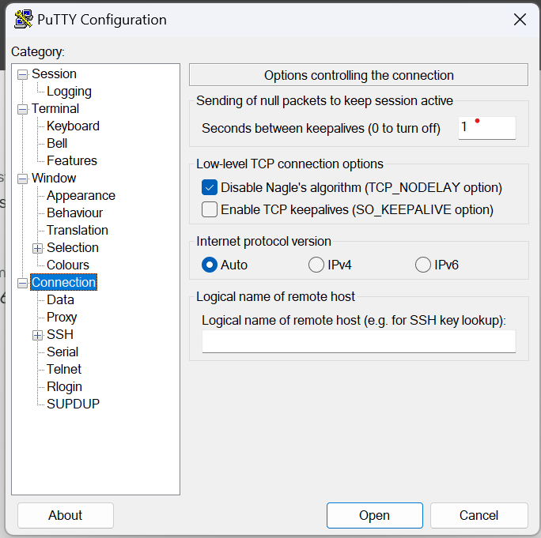

Entering host name and port number to open CLI

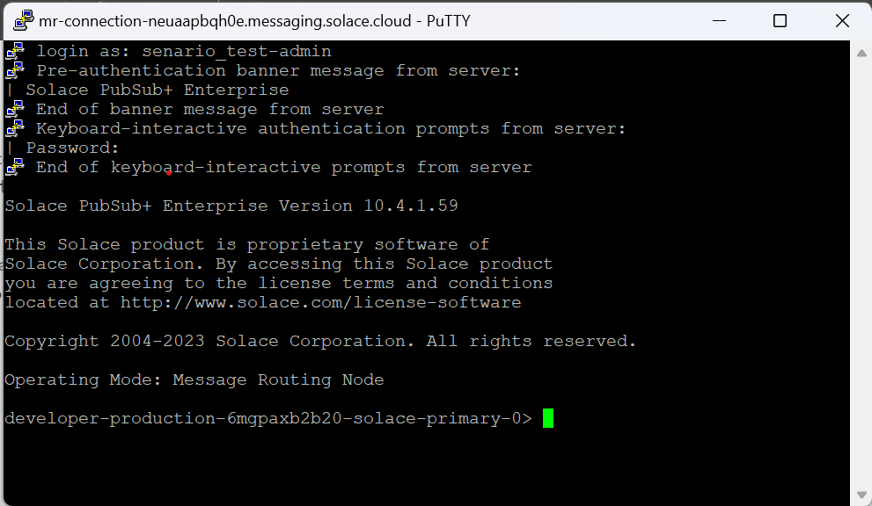

Logging in by entering Management Editor Username and Management Editor password.

Three queues are created using CLI:

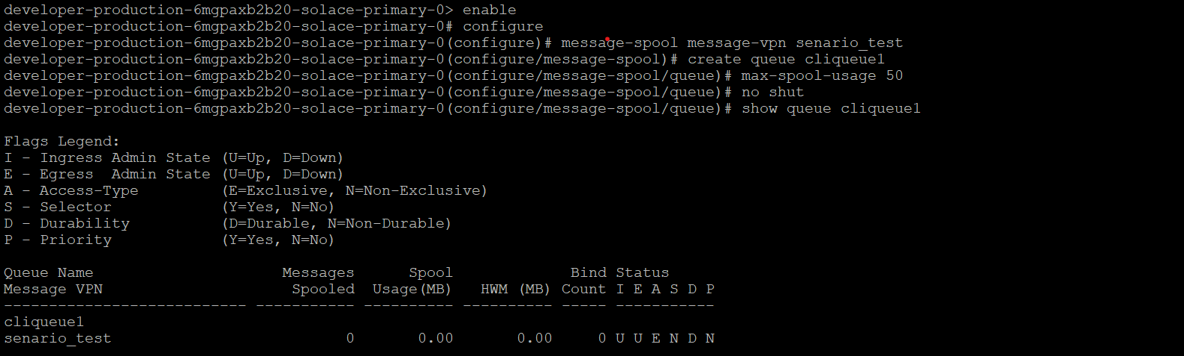



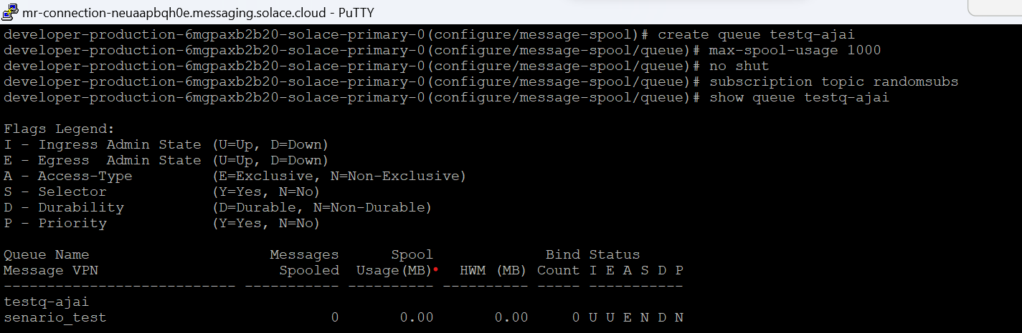

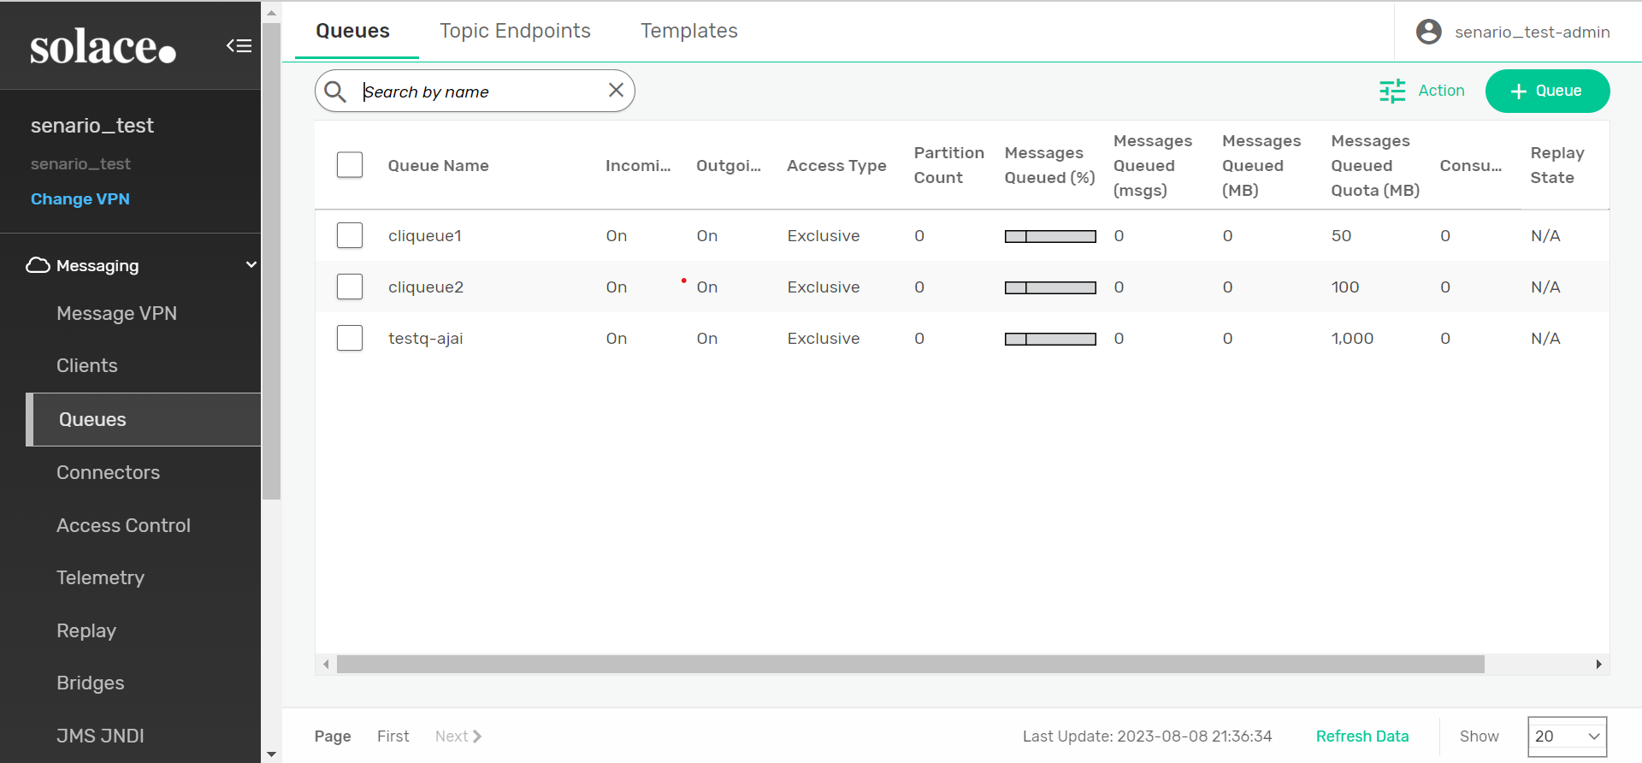

Checking queue <testq-ajai> using “show queue testq-ajai” and details of queue “show queue testq-ajai details” commands :

Show queue :

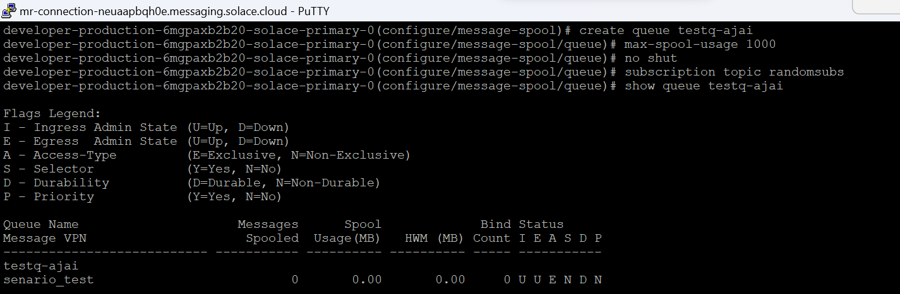

Queue details:

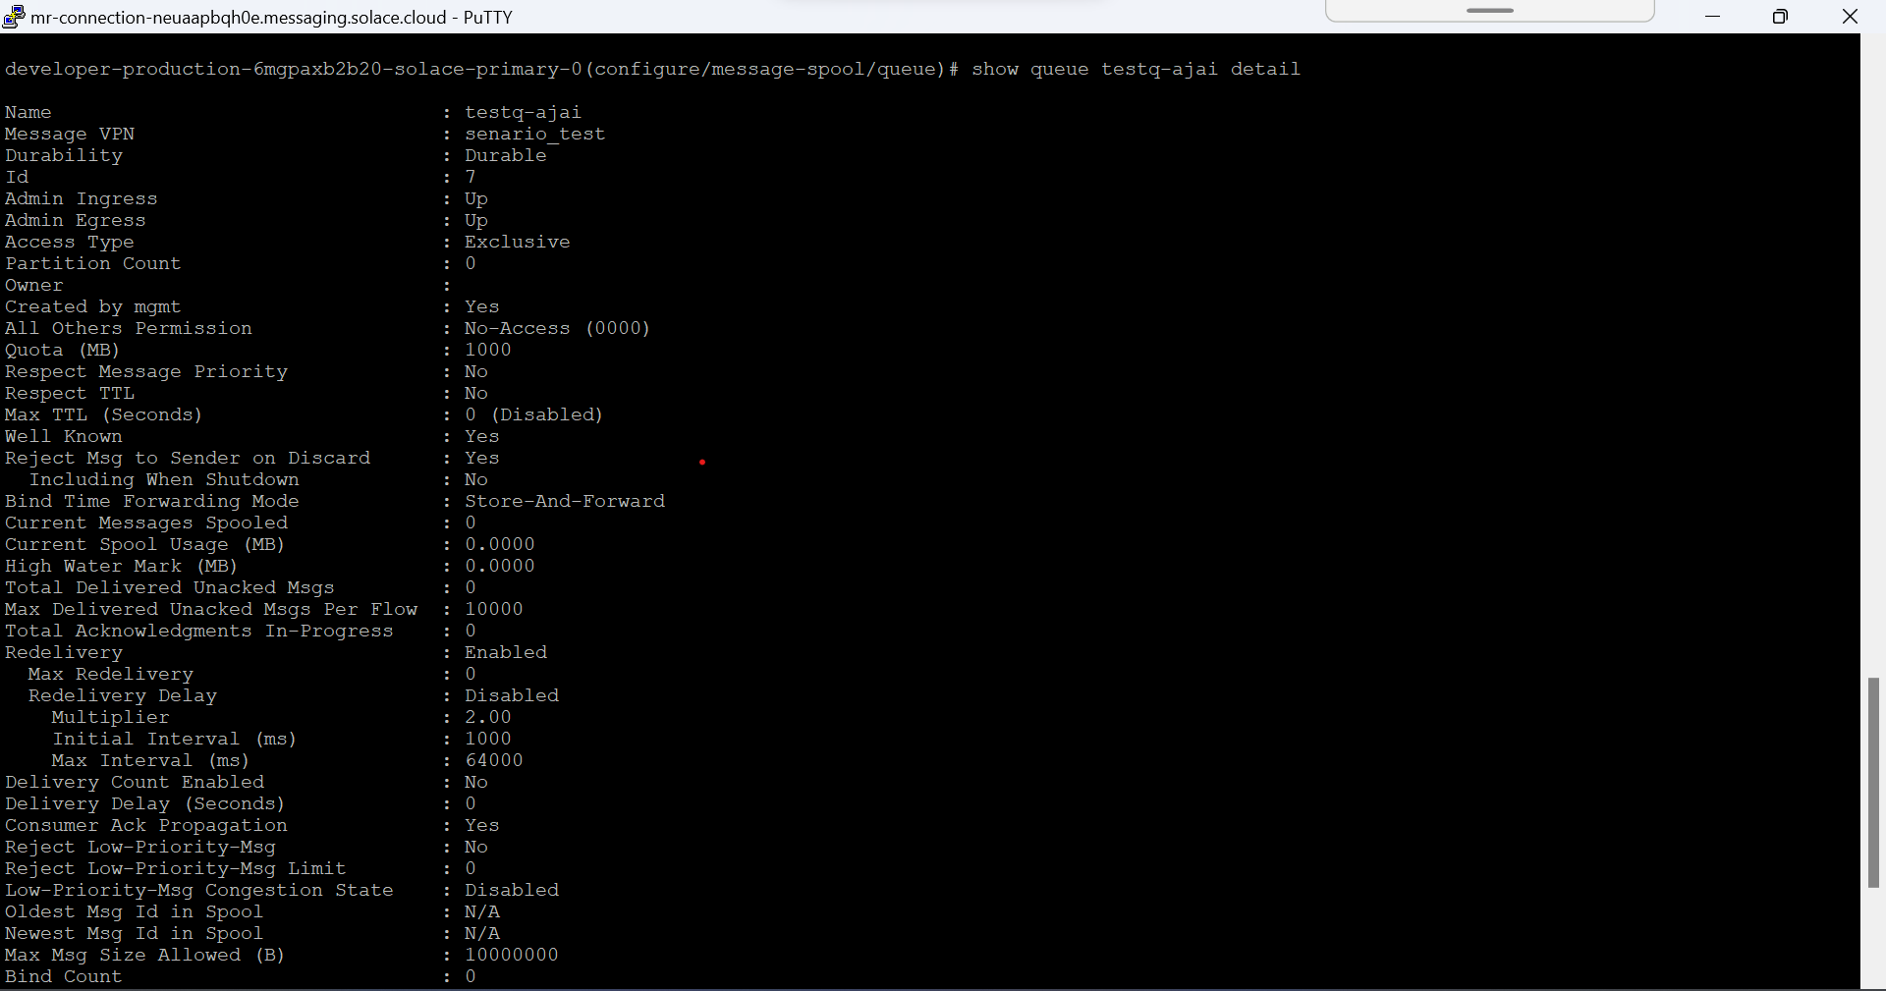

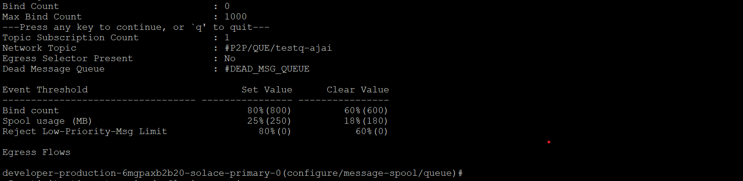

Creating subscription topic in cliqueue1 queue :



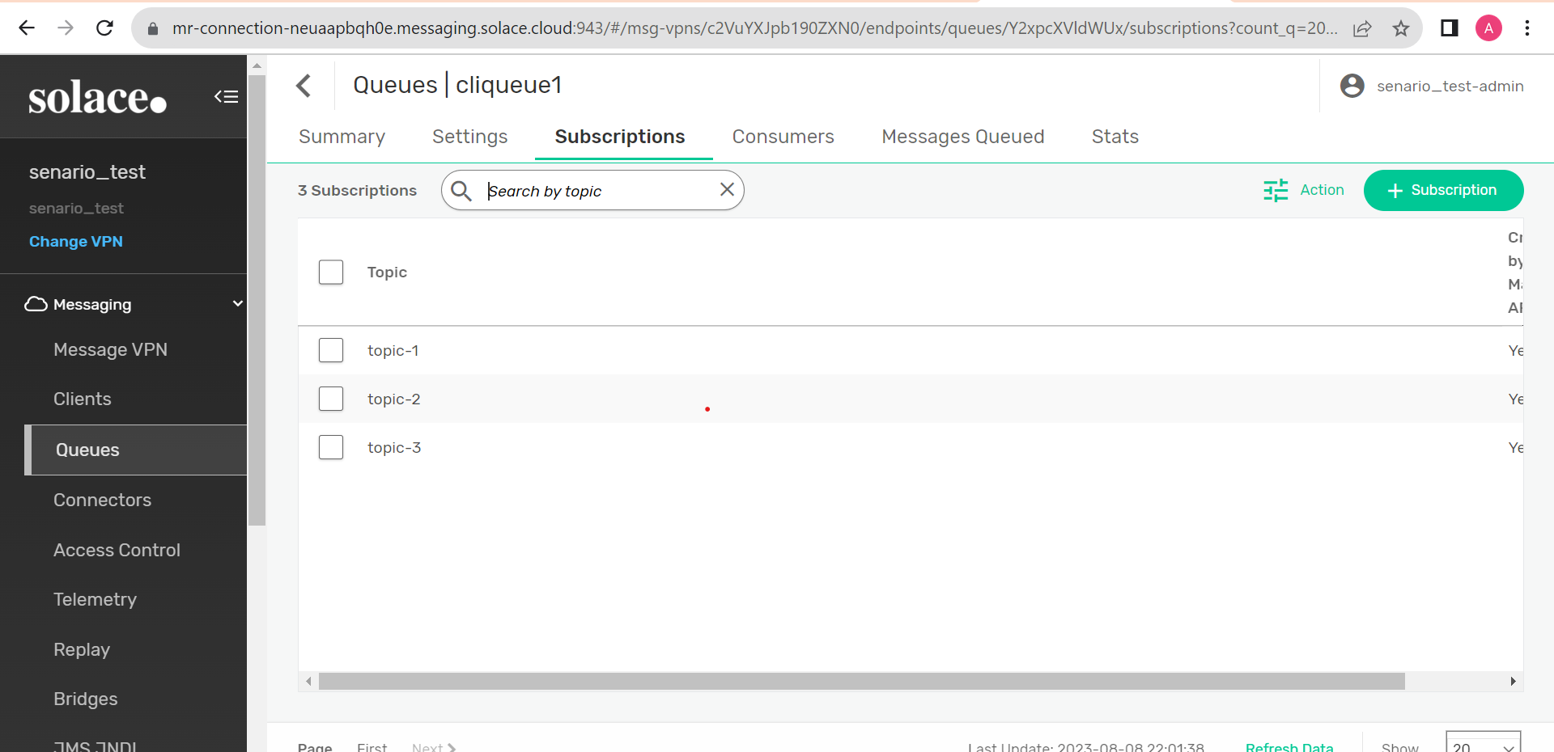

Publishing messages to the topic :

